Here is the moneycontrol site link for each company, in the order I’ve given in each excel file.
- Adani Ports & SEZ – https://www.moneycontrol.com/financials/adaniportsandspecialeconomiczone/consolidated-ratiosVI/MPS#MPS
- Asian Paints – https://www.moneycontrol.com/financials/asianpaints/ratiosVI/AP31
- Axis Bank – https://www.moneycontrol.com/financials/axisbank/ratiosVI/AB16
- Bajaj Finserv – https://www.moneycontrol.com/financials/bajajfinserv/ratiosVI/BF04
- Bajaj Finance – https://www.moneycontrol.com/financials/bajajfinance/ratiosVI/BAF
- Bharat Electronics – https://www.moneycontrol.com/financials/bharatelectronic/ratiosVI/BE03
- Bharti Airtel – https://www.moneycontrol.com/financials/bhartiairtel/ratiosVI/BA08
- Eternal Ltd – https://www.moneycontrol.com/financials/eternal/ratiosVI/Z
- HCL Technologies – https://www.moneycontrol.com/financials/hcltechnologies/ratiosVI/HCL02
- HDFC Bank – https://www.moneycontrol.com/financials/hdfcbank/ratiosVI/HDF01
- Hindustan Unilever – https://www.moneycontrol.com/financials/hindustanunilever/ratiosVI/HU
- ICICI Bank – https://www.moneycontrol.com/financials/icicibank/ratiosVI/ICI02
- Infosys – https://www.moneycontrol.com/financials/infosy/ratiosVI/IT
- ITC – https://www.moneycontrol.com/financials/itc/ratiosVI/ITC
- Kotak Mahindra Bank – https://www.moneycontrol.com/financials/kotakmahbank/ratiosVI/KMB
- Larsen & Toubro – https://www.moneycontrol.com/financials/larsentoubro/ratiosVI/LT
- Mahindra & Mahindra – https://www.moneycontrol.com/financials/mahindramahindra/ratiosVI/MM
- Maruti Suzuki – https://www.moneycontrol.com/financials/marutisuzukiindia/ratiosVI/MS24
- NTPC – https://www.moneycontrol.com/financials/ntpc/ratiosVI/NTP#NTP
- Power Grid Corp – https://www.moneycontrol.com/financials/powergridcorpindia/ratiosVI/PGC
- Reliance Industries – https://www.moneycontrol.com/financials/relianceindustries/ratiosVI/RI
- State Bank of India – https://www.moneycontrol.com/financials/statebankindia/ratiosVI/SBI
- Sun Pharma – https://www.moneycontrol.com/financials/sunpharmaceuticalindustries/ratiosVI/SPI
- Tata Motors – https://www.moneycontrol.com/financials/tatamotors/ratiosVI/TM03
- Tata Steel – https://www.moneycontrol.com/financials/tatasteel/ratiosVI/TIS#TIS
- Tata Consultancy Services (TCS) – https://www.moneycontrol.com/financials/tataconsultancyservices/ratiosVI/TCS
- Tech Mahindra – https://www.moneycontrol.com/financials/techmahindra/ratiosVI/TM4
- Titan Company – https://www.moneycontrol.com/financials/titancompany/ratiosVI/TI01#TI01
- Trent – https://www.moneycontrol.com/financials/trent/ratiosVI/T04#T04
- UltraTech Cement – https://www.moneycontrol.com/financials/ultratechcement/ratiosVI/UTC01#UTC01

For each financial ratio file assigned, open each company link. Scroll down to this:
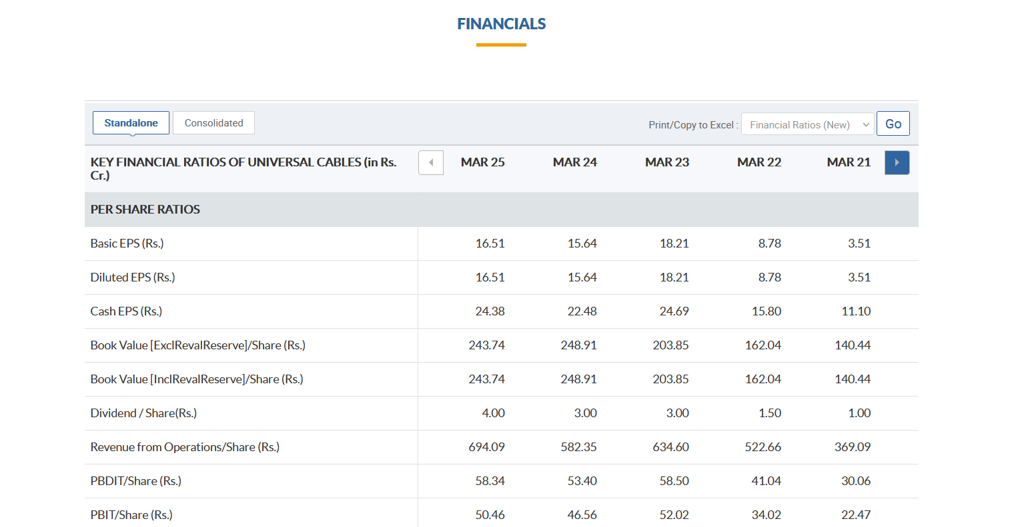
Find the required ratio row.
The rows available are: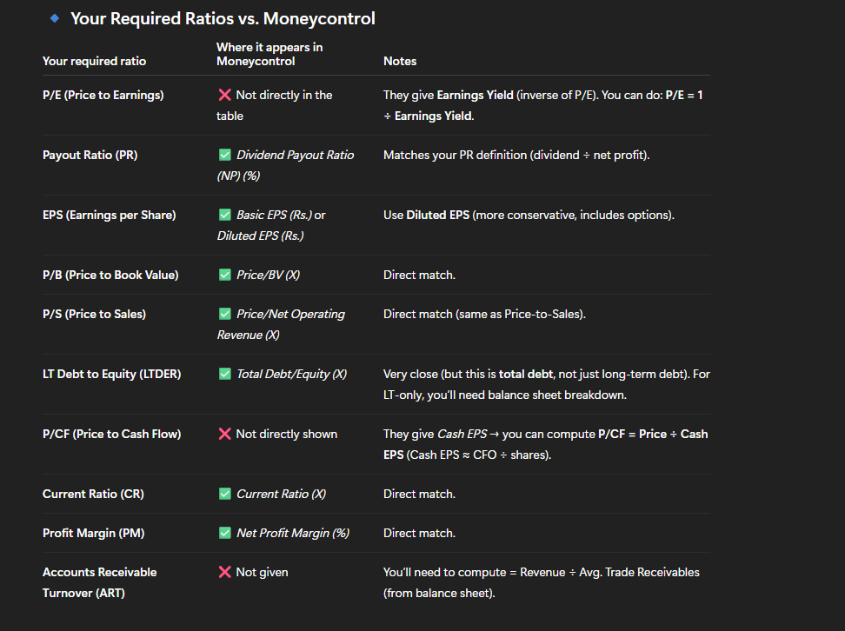

P/E, LTDER, P/CF, ART excel files will be handled later, by me after my interview on tuesday.

Excel file making responsibility:

Subhadip:
Fill: PR, EPS, P/B files

Sagata:
P/S, CR, PM

March 2013 to march 2025 data required.

NOTE: jodi keo onno kono site theke aro quickly ar easily automate korte paris to bhalo, amar just accurate data chai. Ami ei time r modhhe ei way tai peyechi, tora research kore bar korte parle bhalo.

THURSDAY r moddhe tinte file jeno hoye jai. Ami next week tahole college jabo. Ar karo kono problem thakle kal sokale call korbi, dupurer por theke ami available thakbo na.

